LaMPSS Sign In Exercise

- Navigate to the LaMPSS website by clicking the icon on your desktop or navigating to <https://lampss-prep.gov.ns.ca>. Please have your organization ID, user ID and password ready!
- Type your organization ID, user ID and password in the corresponding fields as illustrated below.
- Click Login. You will be taken to your user homepage.
Please do not share your login credentials with anyone. Your login information and user ID are what LaMPSS uses to direct you to your customized user homepage with notifications and tasks assigned specifically to you. Any actions you complete in the system are also tagged with your user ID.
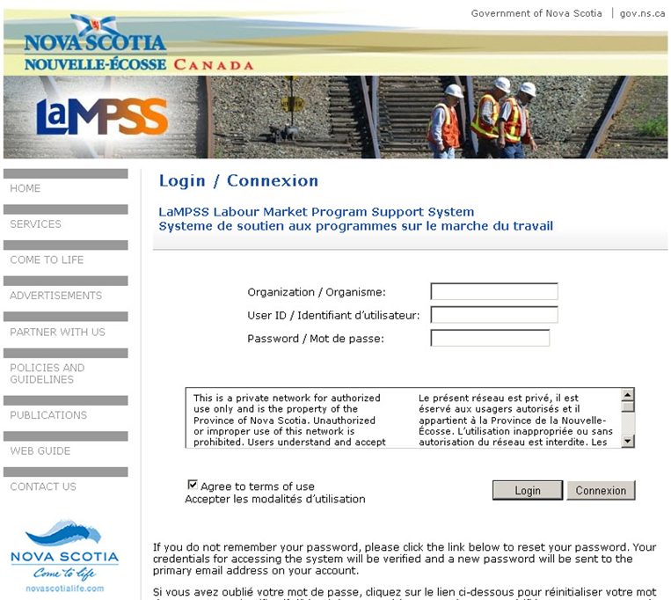
<<end of exercise>>

