Complete RTWAP Development Exercise

- In the “My Task Items Due/Overdue” section of your user homepage locate the develop action plan task for your case/client.
- Click on the task name (“Develop Action Plan”) to navigate directly to the Case Task Page.
  - The develop action plan task will be displayed in the case tasks section of the page
-OR-
- Navigate to the Case Homepage by clicking the recent agrmnts/cases section of the left navigation menu.
- Click on the case ID and name of your client to access the homepage.
  - In the “Case Tasks” section of the homepage locate the develop action plan task and click on the task name (“Develop Action Plan”) to navigate to the Case Task Page.
  - The develop action plan task will be displayed in the case tasks section of the page.
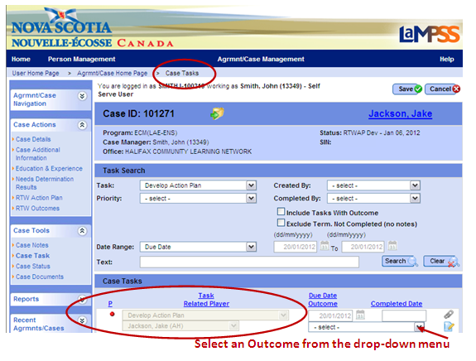

- Select an outcome from the drop-down menu. For this exercise, please indicate that the RTWAP has been developed and signed.
  - Please remember that selecting an outcome of referred out or client not committed will close the case. This action cannot be reversed.
- Click save. You will be redirected to the Case Homepage.
- Notice that:
  - The case header displays the updated status of RTWAP Mgmt.
  - A new task (“Close Action Plan”) was automatically generated by LaMPSS when the action plan was recorded as developed and signed; however, the due date for this task is the last planned intervention end date plus 28 days. This task will only appear on the Case Homepage and User Homepage within 30 days of the due date.
<<end of exercise>>

