Search/Add Person Exercise

Before beginning this exercise review the person information on the Case Intake Form provided at the end of this training workbook.
- Navigate to the Person Search/Add Screen by clicking person management in the top navigation menu.
- Search for the client by SIN:
  - Enter 9 numbers in the SIN field without spaces/hyphens (i.e. 123456789)
  - Two asterisks (**) will appear next to the field if an invalid SIN is entered
  - Click Search
- No search results are found. Click clear to reset the person search criteria.
- Search for the client by last name:
  - Enter the client’s last name (found on the Case Intake Form) in the last name field
  - Click Search
Why search this way? If you enter additional search criteria, the application may exclude the person you are searching for in the search results. In this case you may think that the person does not exist in the registry and add a duplicate record.
- Person search results may appear at the bottom of the page; however, your client is not listed. Complete the data entry of the person information, including all information available on the Case Intake Form, such as:

  - Last Name
  - First Name
  - Middle Initial
  - Gender
  - Marital Status
  - Address
  - Phone
  - SIN
  - Date of Birth

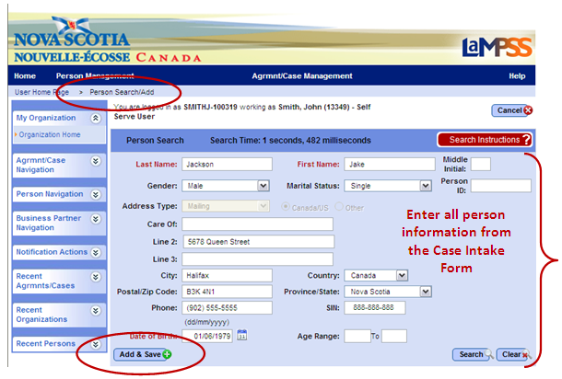

- Click add & save. If any required information has not been provided or LaMPSS identifies invalid information a red error message will display at the top of the screen. Otherwise, the person record is created and you will be taken to the newly created Person Homepage.
As you complete this exercise, take a few moments to become familiar with the menu options and various sections of the Person Homepage.
<<end of exercise>>

Update Person Details Exercise

- Navigate to the Person Homepage by clicking the recent persons section of the left navigation menu.
- Click on the Person ID and name of your client to access their homepage.
- Click the person details link in the left navigation menu under person actions. The Person Details Page will appear displaying the information you entered to create the person record. Review the Case Intake Form and, if necessary:
  - Enter any additional information available about the client such as service language, addresses, phone numbers or email.
  - Enter any known first name and/or last name aliases.
  - Click cancel to return to the Person Homepage at any time without saving your changes.
- Click Save. Your changes will be saved and you will be returned to the Person Homepage.
- Review the person record to ensure you have entered all information, including the Social Insurance Number, accurately for your client.
Remember, you won’t only be updating a person record the first time you add a new person to LaMPSS. Each time a person’s information changes you will need to make updates. Life events such as marriage, divorce, buying a home, having a baby or even minor events such as getting a new cell phone number will require changes to the person details in LaMPSS!

<<end of exercise>>

