Add Case Exercise

- Navigate to the Person Homepage by clicking the recent persons section of the left navigation menu.
- Click on the Person ID and name of your client to access their homepage.
- Click the create case link in the left navigation menu under person actions. If the person has not yet been shared with NS government the Privacy and Accountability Page will appear.
- Click share. This indicates that the case being created and client information should be shared with the Province. LaMPSS will search Nova Scotia Government person records to find potential matches for the client.
  - If a match or potential matches are found, LaMPSS will display those matches and wait for you to select which match you would like to merge with the person record.
  - If no match is found, LaMPSS will display messaging and ask you to select the next button to complete the process of sharing the person information with the Nova Scotia Government.
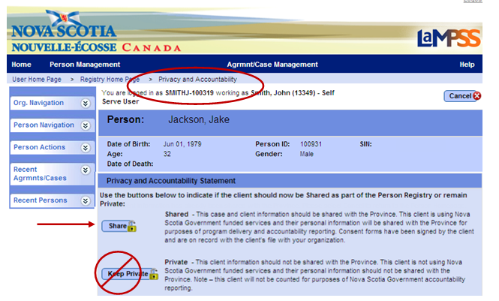
- Click next. This allows you to proceed without merging the person record with any potential matches. You will be redirected to the Add Agrmnt/Case Page.

- Complete the following fields by making selections from the drop-down menus:
  - Agrmnt/Case Manager – Select a case manager.
  - Accountability Reporting – Select your organization’s EAS agreement. Do not select Private.
  - Copy Case Information from Previous Case – Select a case. Available only if the client has had previous cases with your organization.
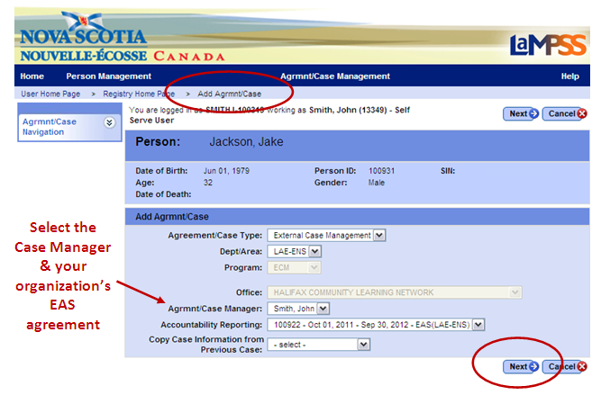

- Click next. You will be redirected to the Registration Details Page.
- Complete the fields on this page. The following four fields are mandatory; however, all available information should be recorded by entering text or making selections from the drop-down menus:
  - Correspondence Language
  - Employment Status
  - Are you a student?
  - Preferred Contact Method
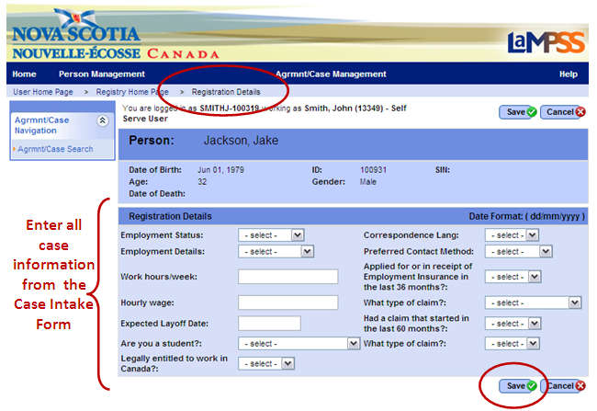
- Click save. You will be redirected to the newly created Case Homepage.
- Write down the six-digit case ID number that appears near the top of the page.
As you complete this exercise, take a few moments to become familiar with the menu options and various sections of the Person Homepage.
<<end of exercise>>

