Enter Case Information Exercise

- Navigate to the Case Homepage by clicking the recent agrmnts/cases section of the left navigation menu.
- Click on the case ID and name of your client to access the homepage.
- Click the additional case information link in the left navigation menu under case actions. You will be taken to the Case Additional Information Page.
- Complete the fields in the referral details/ case information sections of the page. While there are no mandatory fields that must be completed to save the page, all available information should be recorded by entering text or making selections from the drop-down menus/pick lists.
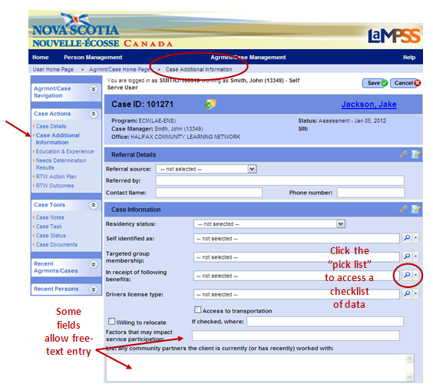
Remember, you can save your progress at any time by clicking save at the top/bottom of the page! When a case screen is saved, LaMPSS will redirect you to the Case Homepage. Follow steps 1, 2 & 3 of this exercise to navigate back to this page.

- Determine if there are any modules listed in the additional case information section at the bottom of the Case Additional Information Page.
  - If no, all case information has been entered. Click save. Move onto the next exercise.
  - If yes (see example below), continue on to steps 6, 7, and 8.
This section may include 0-4 modules.
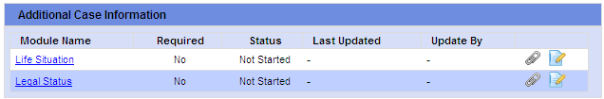
- Select an additional case information module by clicking on the blue, hyperlinked module name. The selected module will open.
- Complete the fields in the additional case information module.
  - The specific questions in each module as well as the order in which they appear on the page is dependent on your organization’s LaMPSS configuration.
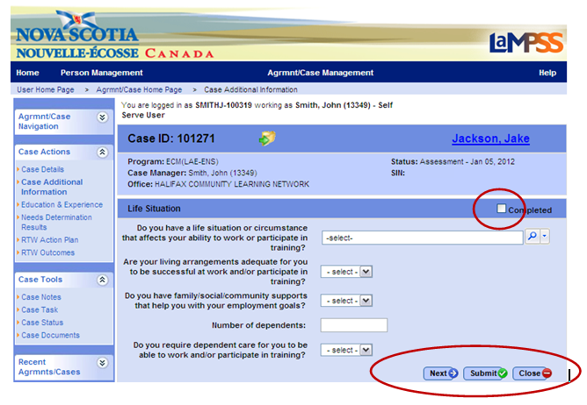

- Select the checkbox in the module header (see example above) to indicate that all data has been entered.
  - Please note, if the module is required by your organization, all information must be entered and this checkbox selected before LaMPSS will allow you to complete the assessment task for the case.
- Click submit. You will be returned to the main Case Additional Information Page.
  - When more than 1 additional case information modules exist, the next button (see example above) can be used to navigate directly from one module to the next.
- Click save. All updates to the Case Additional Information Page will be saved. You will be redirected to the Case Homepage.
<<end of exercise>>

