Add Case Notes Exercise

Case notes can be created, edited and viewed at various stages of a case. Use the steps below to create a case note anywhere the add note icon appears on a LaMPSS screen.
- Navigate to the Case Homepage by clicking the recent agrmnts/cases section of the left navigation menu.
- Click on the case ID and name of your client to access the homepage.
- Click the education and experience link in the left navigation menu under case actions. You will be taken to the Education & Experience Page.
- Click on the add note icon. The new note window will appear.
  - The add note icon appears in several places on this page. For this exercise you can use any one of these icons.
- Complete the fields in the new note window.
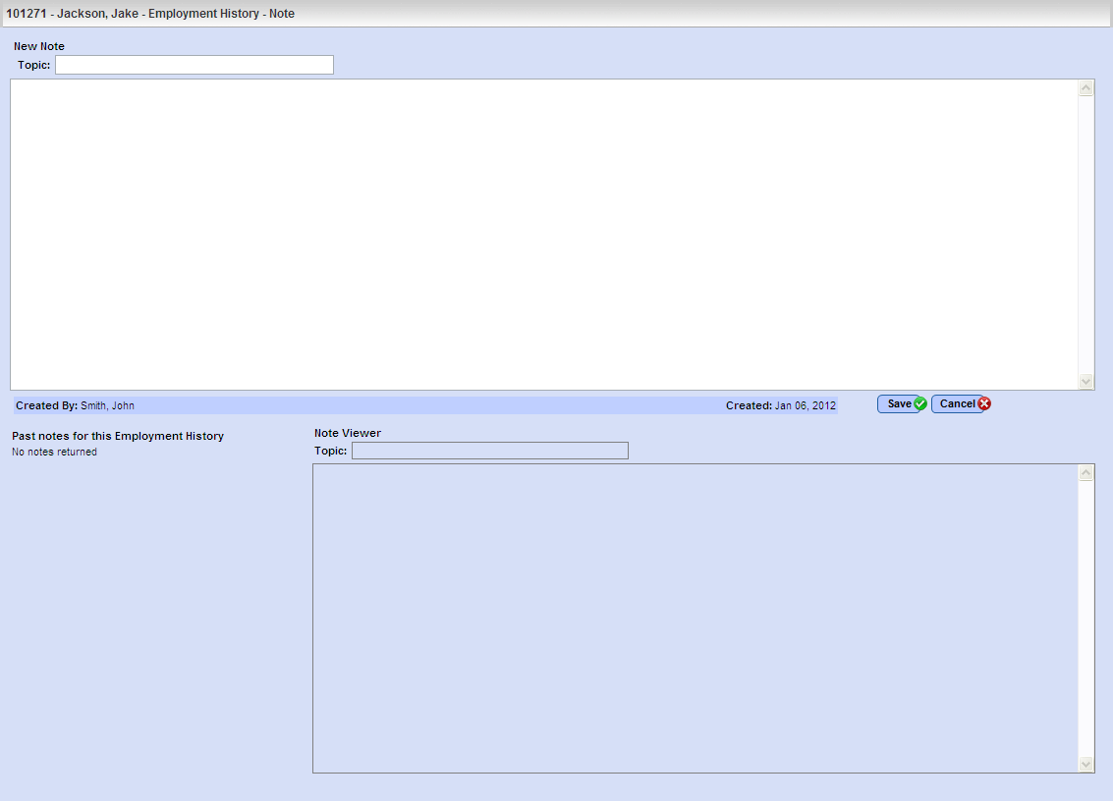
Enter the note in this text box

Remember, notes should always be long enough to capture any relevant information and explain it thoroughly enough that another user can view and understand the note. Don’t use notes, however, to restate information or describe a situation that is evident by reviewing the case screens.
- Click save. LaMPSS will conduct an automatic spell check of the note. Once the spell check is complete you will be redirected to the Education & Experience Page.
- Notice that:
  - The add note icon has changed to the add/view notes icon .
  - The add/view notes icon is used to add additional notes as well as to view/edit existing notes
Please note, best practice is always to create a new note to provide additional information instead of editing an existing note.
- Click the add/view notes icon. The note window will open with the previously created note in the lower left-hand corner under the past notes heading.
  - To view the existing note click view. The note will appear in the note viewer.
  - To edit the existing note click edit. Make the necessary revisions to the topic or body of the note.
Please note, notes are locked for editing after 30 days.
- If any changes were made, click save. Otherwise click cancel to exit the note window. You will be redirected to the Education & Experience Page
<<end of exercise>>

