Location Information
Location | Folly Lake, Colchester County, Nova Scotia (PID 20131264)
Size | Site Total Area Estimated Maple Sugar Stand Area  A 20 hectares (49.4 acres) 17 hectares (42.0 acres)  B 38 hectares (93.9 acres) 26 hectares (64.2 acres)  C 15 hectares (37.1 acres) 8 hectares (19.8 acres)
Site Access | The site is accessible from Route #4 via a road (locally known as Sutherland’s Lake Road) on land owned by Northern Timber Nova Scotia Corporation (PID 20318416). There is a trail on the site leading to the location of a former sugar bush camp site.  It is the Applicant’s responsibility to obtain all necessary access agreements required over private lands to access the Crown parcel outlined in this site profile.  The Applicant is also required to contact the local snowmobile club regarding the shared use of roads/trails during snowmobile season.  The Department of Natural Resources does not guarantee access to this site through privately owned lands; however, DNR has contacted Northern Timber Nova Scotia Corporation to discuss the requirements to gain access to the site. Northern Timber has indicated it would provide an access agreement (Road Usage License Agreement) to the successful Applicant. As part of preparing an application for Folly Lake, the Applicant must contact Northern Timber Nova Scotia Corporation to understand the terms of the agreement and the associated costs.  The contact person for road access agreements at Northern Timber Nova Scotia Corporation is:  Heidi Higgins  Phone (902)752-8461 Ext. 249  The cost of any access agreements with private land owners is the responsibility of the Applicant during the term of the Crown land lease. A copy of any required access agreement must be submitted to the Department of Natural Resources prior to issuance of a lease.

Regional View Map

(Please double-click on the image to open a PDF version of the map)

Local View Map

DNR Forest Inventory Interpretation Map

Data File (requires Google Earth software)

(Please double-click on the icon to view the information)

Site Characteristics
Selected Photographs | 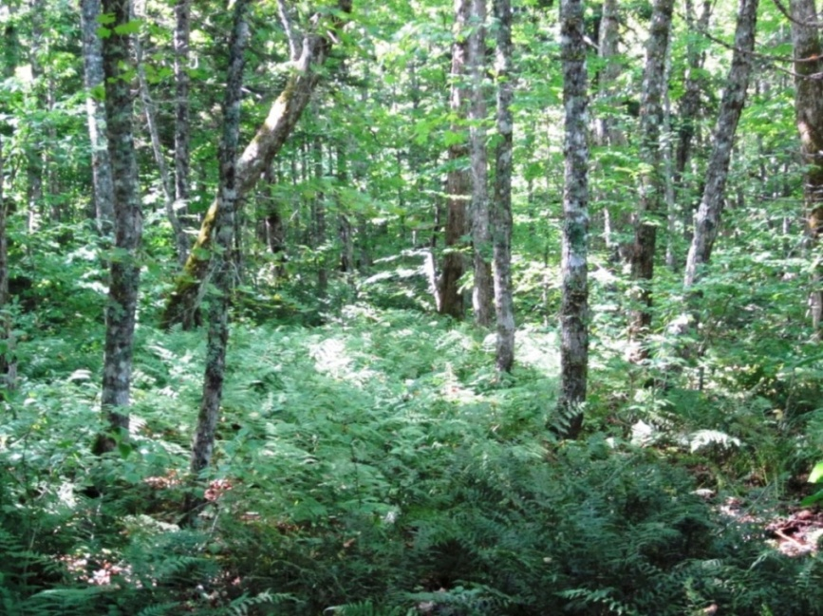  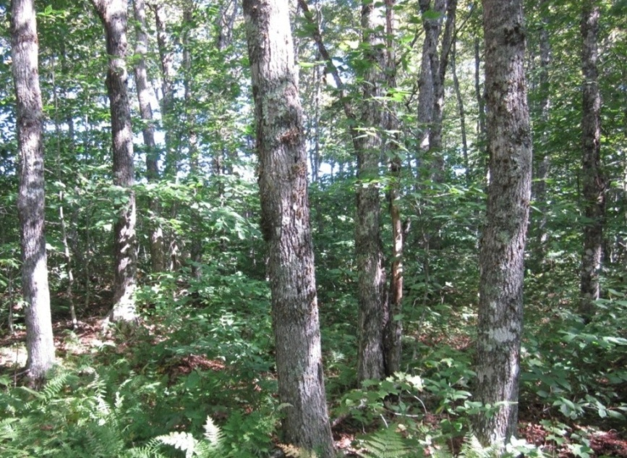  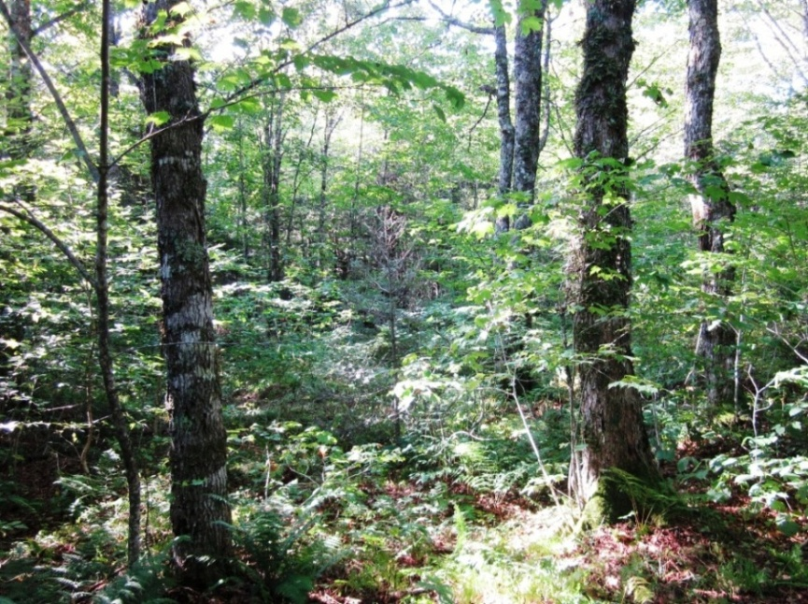  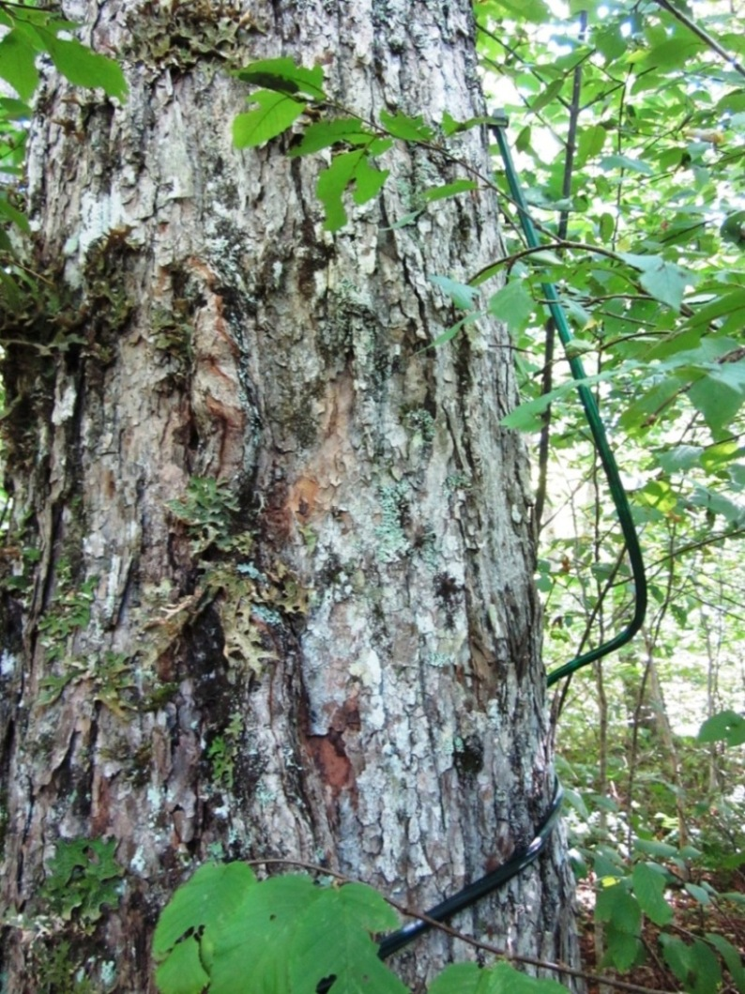  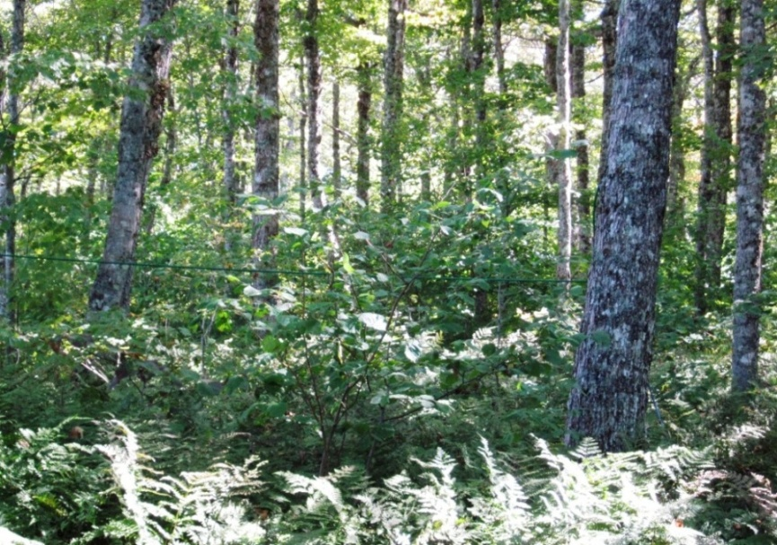
Elevation Range | Approximately 200 meters to 305 meters above sea level.
Sugar Maple Stands - Sites A, B and C  Based on Forest Inventory Interpretation Data (Forestry Division,  Nova Scotia Department of Natural Resources)  Source: http://novascotia.ca/natr/forestry/maps-and-forest-info.asp | The maple stands identified in these areas met the following search criteria:  - Average tree height of greater than 12 metres.  - Average breast height diameter greater than 19 centimetres.  - Average Sugar Maple species percentage greater than 40 % of stand.  Note: Applicants must perform an independent assessment of the maple sugar stands to determine the viability of commercial operations.

Pricing Information
Annual Rent | Site Annual Rent Amount ($)  A $888  B $1,689  C $667

Special Conditions
Abandoned Maple Sugar Production Equipment in Site A | Applicants must inspect Site A and assess the impact of the abandoned equipment on the proposed operations. Appropriate awareness and care must be used when travelling in this area to avoid possible injury.  Site A has remnant infrastructure, which was part of a previous maple sugar operation. This includes a large quantity of plastic collection tubes and wire hangers. The successful Applicant will be required to clean up the remnant equipment during installation of new sap collection equipment and remove all abandoned equipment from the leased area.  Applicants must describe the proposed plan for removal and disposal in their application.
Site Selection Options for Applicants | The Applicant must submit an application that includes, at minimum, Site A. The following are the possible options for Folly Lake:  - Site A or,  - Sites A and B, or  - Sites A and C, or  - Sites A, B and C.

