Location Information
Location | Leamington, Cumberland County, Nova Scotia (PID 25139445)
Size | Total Area Estimated Maple Sugar Stand Area  31 hectares (76.6 acres) 16 hectares (39.5 acres)
Site Access | The site is accessible from Rodney Road via Gilroy Road, a portion of which is on lands owned by the Municipality of Cumberland and passes besides the Springhill Water Utility Treatment Plant (PID 25467077). Also, approximately 100 m of Gilroy Road is located on land parcel PID 25376773.  Beyond the Gilroy Road, there is a network of woods roads on Crown lands. A gravel road on Crown lands leads close to the Leamington 2 site.  The Department of Natural Resources does not guarantee access to the sites through privately or municipally owned lands; however, DNR has contacted the Municipality of Cumberland to discuss the requirements to gain access to the site. The Municipality of Cumberland has indicated it would provide an access agreement (Letter of Authority) to the successful Applicant to travel over PID 25467077. If the Applicant plans to use the existing road adjacent to the Springhill Water Utility Treatment Plant, the Applicant must contact the Municipality of Cumberland to understand the terms of the agreement and any associated costs. An agreement template is provided here for reference purposes.  The contact person for road access agreements at the Municipality of Cumberland is:  Brian Herteis, Capital Projects Engineer  Phone: (902) 597-2496  Neither the Municipality of Cumberland nor DNR can ensure that the roads will be ploughed and maintained so that access is always available to the site.  Important!  - Applicants may suggest alternate access arrangements to the site.  - It is the Applicant’s responsibility to obtain all necessary access agreements required over private or municipal lands to access the site described in this document.  - The cost of any access agreements with private or municipal land owners is the responsibility of the Applicant during the term of the Crown land lease.  A copy of any required access agreement must be submitted to the Department of Natural Resources prior to issuance of a lease.

Regional View Map

(Please double-click on the image to open a PDF version of the map)

Local View Map

DNR Forest Inventory Interpretation Map

Data File (requires Google Earth software)

(Please double-click on the icon to view the information)

Site Characteristics
Selected Photographs | 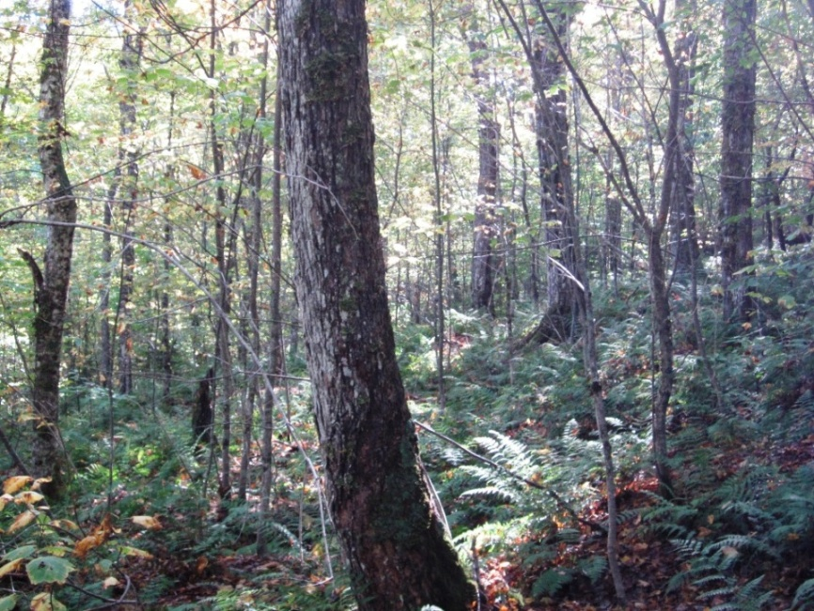  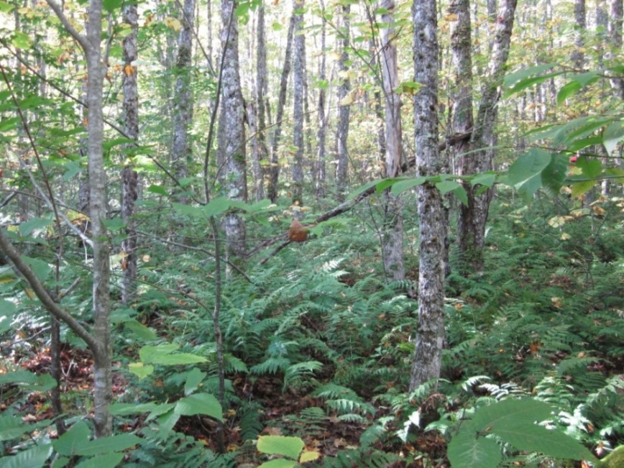  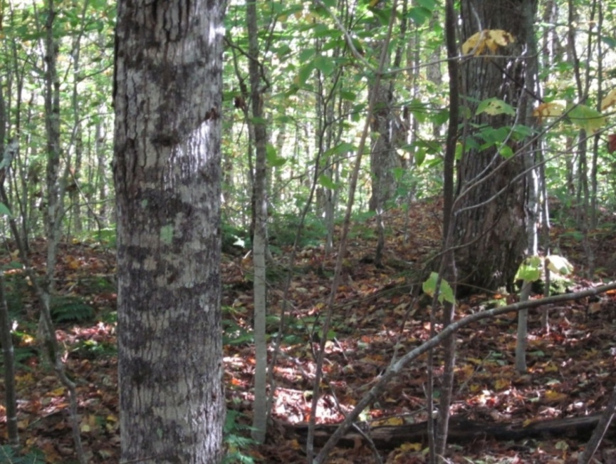
Elevation Range | Approximately 125 meters to 185 meters above sea level.
Sugar Maple Stands  Based on Forest Inventory Interpretation Data (Forestry Division,  Nova Scotia Department of Natural Resources)  Source: http://novascotia.ca/natr/forestry/maps-and-forest-info.asp | The maple stands identified in these areas met the following search criteria:  - Average tree height of greater than 12 meters.  - Average breast height diameter greater than 19 centimeters.  - Average Sugar Maple species percentage greater than 40 % of stand.  Note: Applicants must perform an independent assessment of the maple sugar stands to determine the viability of commercial operations.

Pricing Information
Annual Rent | Annual Rent Amount ($)  $1,377

Special Conditions
Springhill Water Utility Leamington Brook Watershed Area | The site is located within the watershed of the Springhill Water Utility. All activities conducted in the watershed must consider protection of the water resource/supply for the Municipality of Cumberland.  An emergency response clean-up kit must be carried in all vehicles travelling in the watershed area.

