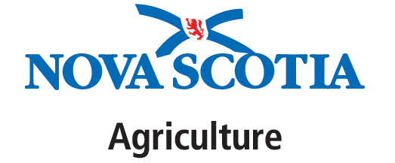

VENDOR LIST FOR SUBMISSION BY ORGANIZER OF PUBLIC MARKET

PUBLIC MARKET INFO
Public Market Name and Location:
Organizer Name:
Organizer Phone:
Organizer E-Mail:

PLEASE LIST BELOW ALL VENDORS WHO ARE:
a) Selling Schedule A food products, per the Food Safety Guidelines for Public Markets (2010); and
b) Vendors selling hot or cold beverages that do not fall under Schedule A food products (e.g., tea, coffee, reconstituted cold drinks).

*If the market is only open one day/ week, disregard this column

VENDOR  NAME | VENDOR PHONE # | VENDOR  E-MAIL | NSDA PERMIT HOLDER?  (Y/ N) | LIST OF FOODS SOLD | DAY OF WEEK SELLING FOOD*

