Apply for Funding (part 1) Exercise

- Navigate to the Case Homepage by clicking the recent agrmnts/cases section of the left navigation menu.
- Click on the case ID and name of your client to access the homepage.
- Click the RTW action plan link in the left navigation menu under case actions. You will be taken to the Action Plan Summary Page.
- In the action plan, select the button in the row of the appropriate intervention. The apply for funding popup will appear:
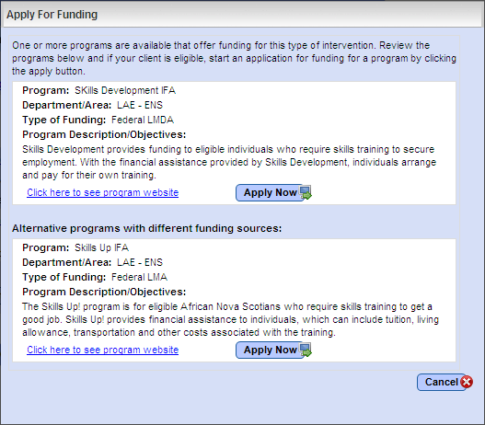

- Click apply now for the Skills Development IFA program. You will be re-directed to the application package screen.
- Review the items listed in the case elements section of the application checklist. If any case elements have a status of incomplete, navigate to the associated screen and enter all required information to complete that case element:
  - E.g. If needs determination is showing as incomplete, navigate to the Needs Determination Results Page and ensure you have completed at least the 1st version of the needs determination.
- Click save. You will be re-directed to the Action Plan Summary Page.

<<end of exercise>>

Apply for Funding (part 2) Exercise

- Navigate to the Case Homepage by clicking the recent agrmnts/cases section of the left navigation menu.
- Click on the case ID and name of your client to access the homepage.
- Click the RTW action plan link in the left navigation menu under case actions. You will be taken to the Action Plan Summary Page.
- In the action plan, select the button in the row of the appropriate intervention. You will be returned to the application package screen you were working on in the previous exercise.
- Review the items listed in the forms/documents section of the application checklist. If any forms/documents have a status of missing you must attach a document OR indicate that the document will be submitted as a hard/paper copy. If any forms/documents have a status of optional you wil need to determine whether that form/document should be submitted with the application for your client.
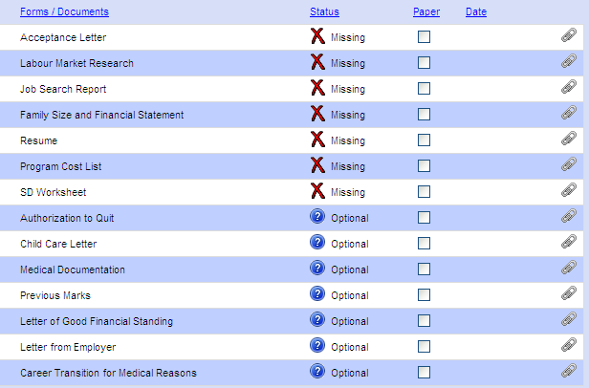
Attach each document using the paperclip icon

- For the purposes of this exercise we will create a sample document that you will attach to the application package. Although this would not work in the ‘real world’, because ENS verifies all document attachments you submit with an application, for training this will allow us to submit our application package without spending too much time creating the required documents. The steps to create this sample document are as follows:
  - Navigate to the desktop of your computer
  - Right click your mouse
  - Select New > Microsoft Office Word Document. The document will appear on your desktop.
  - Double-click the document to open it
  - Type 1-2 lines of text
  - Save and close the document
- Following the steps we reviewed during the presentation, attach this newly created document to the application package to satisfy all of the form/document requirements.
  - Don’t forget to select the appropriate document topic to match each item in the application checklist! (e.g. Select a topic of acceptance letter for the document attached to the acceptance letter field)
- For one form/document do not add any an attachment but instead select the checkbox to indicate you will be submitting a hard/paper copy of that document.
- Click save. You will be re-directed to the Action Plan Summary Page.

<<end of exercise>>

Apply for Funding (part 3) Exercise

- Navigate to the Case Homepage by clicking the recent agrmnts/cases section of the left navigation menu.
- Click on the case ID and name of your client to access the homepage.
- Click the RTW action plan link in the left navigation menu under case actions. You will be taken to the Action Plan Summary Page.
- In the action plan, select the button in the row of the appropriate intervention. You will be returned to the application package screen you were working on in the previous exercise.
  - Now that you have completed the case elements and forms/documents, your application checklist should appear similar to this:
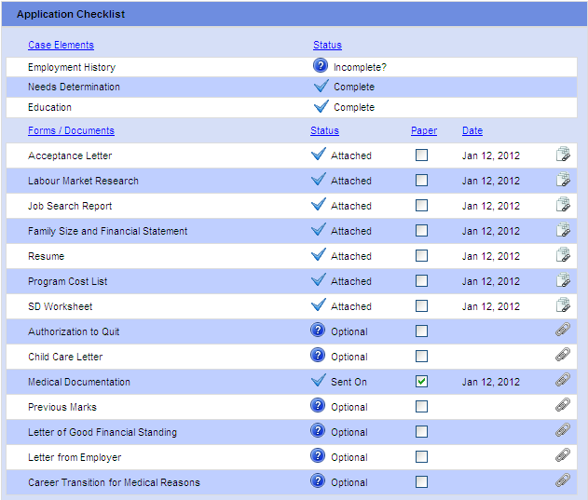

  - Notice that when we last saved this screen, LaMPSS changed the status to “Sent On” for the item we indicated would be submitted in hard/paper copy. LaMPSS also assigned a date to reflect when each item was attached.
- In the case manager’s summary statement section of the Application Package Page select a response for each of the following three questions:
  - Do you support this Return to Work Action Plan?
  - Have both you and the client signed the Case Manager’s statement?
  - If spousal information was collected, has the applicant’s spouse signed the consent form?
For this exercise, assume that you do support the RTWAP and all documentation has been signed by both parties.
- Write a case manager’s statement in the text box provided.
Remember, any information that has been entered on other LaMPSS screens (e.g. education history, employment goal, barriers) does not need to be entered again here.
- Click save. You will be re-directed to the Action Plan Summary Page.
- In the action plan, select the button in the row of the appropriate intervention. You will be returned to the application package screen.
- Click submit application at the bottom of the screen. A popup window will ask you to confirm that you wish to submit the application.
- Click OK to continue. An icon will appear while the application is submitting to show that the PDF of the case manager’s statement is being created and then a message will appear to confirm that the application has been successfully submitted.
- Write down the agreement ID appearing in the message then click OK.
  - At this point you would immediately mail any supporting documents you have indicated would be submitted in hard/paper copy.
<<end of exercise>>

