Complete Intake Exercise

- In the “My Task Items Due/Overdue” section of your user homepage locate the intake task for your case/client.
- Click on the task name (“Complete Intake”) to navigate directly to the Case Task Page.
  - The intake task will be displayed in the case tasks section of the page
-OR-
- Navigate to the Case Homepage by clicking the recent agrmnts/cases section of the left navigation menu.
- Click on the case ID and name of your client to access the homepage.
  - In the “Case Tasks” section of the homepage locate the intake task and click on the task name (“Complete Intake”) to navigate to the Case Task Page.
  - The intake task will be displayed in the case tasks section of the page.
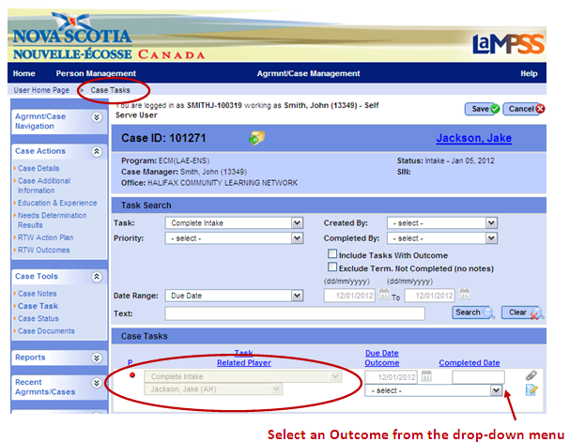

- Select an outcome from the drop-down menu. For this exercise, please indicate that the intake process is complete.
  - Please remember that selecting an outcome of self-serve only, group services only, or referred out will close the case. This action cannot be reversed.
- Click save. You will be redirected to the Case Homepage.
- Notice that:
  - The case header displays the updated status of assessment
  - A new task (“Complete Assessment”) was automatically generated by LaMPSS when the intake process was completed.
<<end of exercise>>

