Enter Education & Experience Exercise

- Navigate to the Case Homepage by clicking the recent agrmnts/cases section of the left navigation menu.
- Click on the case ID and name of your client to access the homepage.
- Click the education and experience link in the left navigation menu under case actions. You will be taken to the Education & Experience Page.
- Complete the fields in the education/training section of the page. Use the add another button to provide details on all past and current education and training, including any training or courses funded by ENS. For each record provide:
  - Education/Training/License name
  - Source/Location
  - Results
  - From/To dates
A minimum of one row of information must be entered before assessment can be completed.
- Click add another in the employment history section of the page. The Employment Details Page will appear.
- Complete the fields on this page. The following six fields are mandatory; however, all available information should be recorded:
  - Employer Name
Selecting an employer from the drop-down will auto-fill the address section.
  - Employer Address
  - Job Title
  - NOC Code
  - From date
  - Employment Type
- Click submit. You will be returned to the Education & Experience Page.
- Repeat steps 5-7 for each instance of employment.

You should capture the client’s employment history now and over the last 5 years. Also include any significant employment that is relevant to an ENS funded application. ENS defines significant employment as any employment record where the client has been with one employer for 5 years or more.
- Complete the fields in the other skills/knowledge section of the page. Use the add another button to add as many rows as required. For each record provide:

  - Skill/Knowledge name
  - Skill/Knowledge Detail

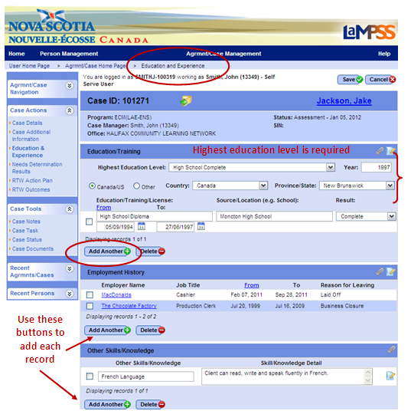

- Click save. You will be redirected to the Case Homepage.
<<end of exercise>>

