Enter Needs Determination Exercise

- Navigate to the Case Homepage by clicking the recent agrmnts/cases section of the left navigation menu.
- Click on the case ID and name of your client to access the homepage.
- Click the needs determination link in the left navigation menu under case actions. You will be taken to the Needs Determination Results Page.
- In the needs determination section of the page, select “Add a new Needs Determination” in the version field from the drop-down menu.
- In the employment goal section of the page, use the drop-down menu to select which of the following employment goals you have established with the client:
  - Full time employment
  - Full capacity employment
  - Self employment
Full capacity is an employment goal specific to persons with disabilities and indicates the full extent of the client’s ability to work.
- Enter a job title in the job preference 1 field.
- Click the NOC search icon to open the NOC (National Occupation Classification) Code Search popup window.
- Search for and select a corresponding NOC code for job preference 1. Use the NOC Code Search Demonstration script for instructions.
Remember, you can save your progress at any time after this point by clicking save at the top/bottom of the page! When a case screen is saved, LaMPSS will redirect you to the Case Homepage. Follow steps 1, 2 & 3 of this exercise to navigate back to this page.
- Repeat steps 6-8 for each job preferences 2 & 3, if required.
Please note, if a client is applying for funding and has more than one job preference identified on their needs determination the information submitted supporting any application for funding to ENS will need to address each of the job preferences listed.

- Click the add another button in the employment barrier section of the page. A new, blank row will be added to the page. Use the add another button to add as many rows as required. For each record provide:
  - Dimension
  - Barrier type
  - Relevant to goal
  - Barrier description (click the add/view barrier description icon to enter text describing each barrier)
Remember, use case notes to capture any relevant information! They are an important tool to capture the “thinking” that has gone on at different points in the case management lifecycle.
- Select the checkbox in the needs determination header to indicate that this version of the needs determination is completed.
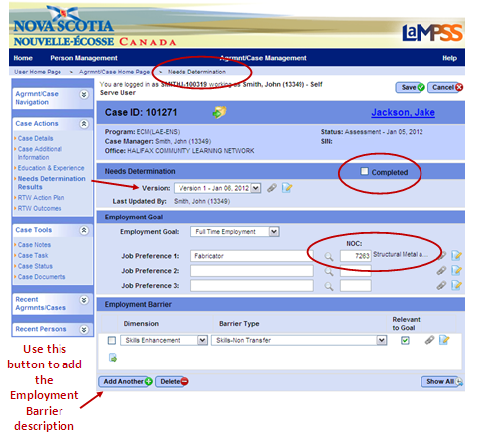

- Click save. A popup message will appear: “By selecting completed you are locking this version. No further changes to the version will be allowed. Are you sure you want to complete this version?”
Please note, a minimum of 1 version of the needs determination must be completed before the case can move into RTWAP development status.
- Select OK. You will be redirected to the Case Homepage.
<<end of exercise>>

