Add Interventions Exercise

Please note, during this exercise you must add a minimum of 1 non-funded intervention and 1 ENS funded Skills Development intervention. Practice adding additional interventions if time allows.
- Navigate to the Case Homepage by clicking the recent agrmnts/cases section of the left navigation menu.
- Click on the case ID and name of your client to access the homepage.
- Click the RTW action plan link in the left navigation menu under case actions. You will be taken to the Action Plan Summary Page.
- Click add another. The Action Plan Details Page will appear.
- Complete the fields on this page. The following six fields are mandatory; however, all available information should be recorded:

  - Dimension
  - Intervention Type
  - Type of Funding
  - Delivery Model
  - Start/End Date

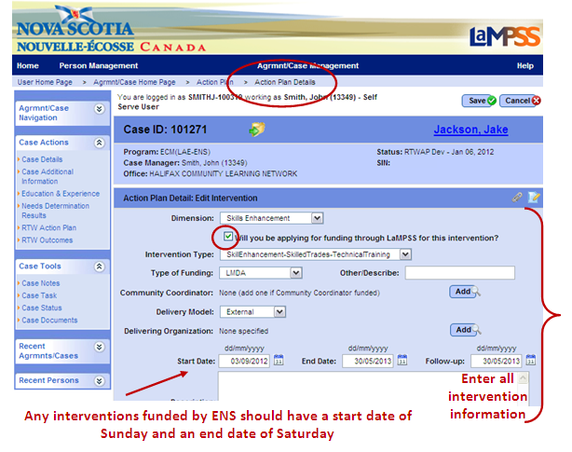

Please note, the checkbox for “Will you be applying for funding through LaMPSS for this intervention” should be used for any interventions that will result in an application for funding from an ENS program (e.g. Skills Development, Skills Up!)
- If the delivery model is external or the intervention will be funded by a community coordinator, click the corresponding add button. A business partner search section will open within the add intervention page.
- Search for a business partner by entering search criteria in any of the fields including, but not limited to, name, address or services provided.
- Click search. Any search results will appear at the bottom of the page.
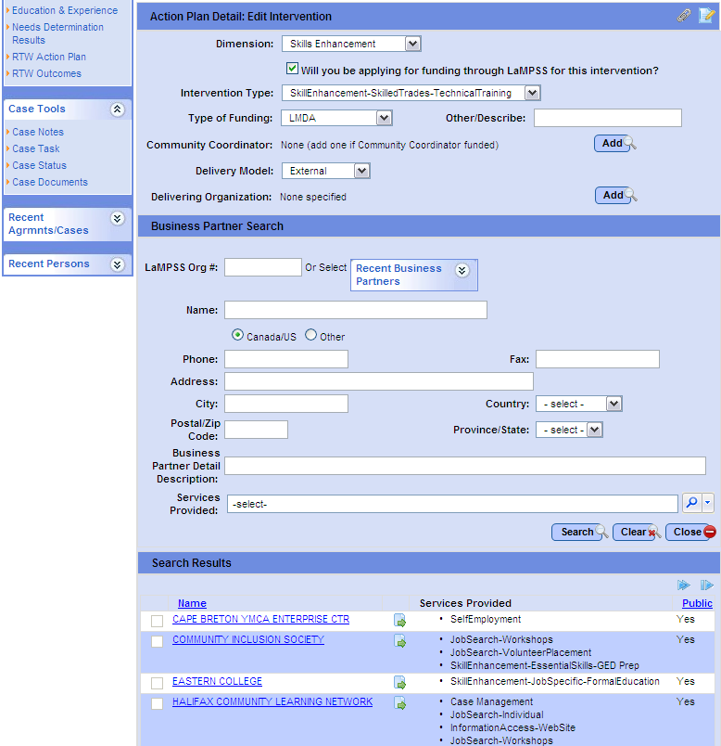
Enter search criteria
Review search results and select the desired business partner
- Select a business partner as the delivering organization/community coordinator by clicking the blue, hyperlinked organization name. The business parter search will close.
  - The selected business partner is now listed on the Action Plan Detail Page.
- Click Save. You will be returned to the Action Plan Summary Page. The newly added intervention will appear in the list of action plan interventions.
  - If you selected the checkbox to indicate that this intervention will be associated with an application for funding, the apply for funding button will appear within the intervention on the Action Plan Summary Page.
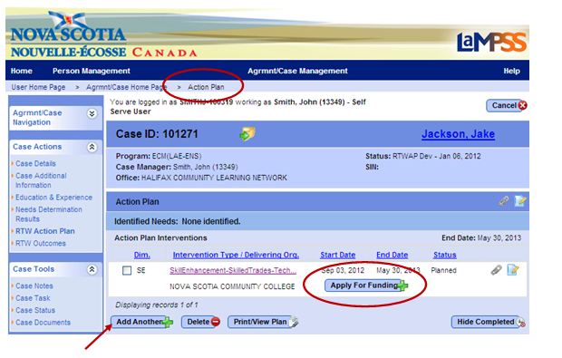

- Repeat steps 4-10, beginning by selecting the add another button, to add all desired action plan interventions.
<<end of exercise>>

